**SSN COLLEGE OF ENGINEERING**

**Department of Computer Science and Engineering CS6712 Grid and Cloud Computing Laboratory**

##### Assignment -7 : Private Cloud Setup using OpenNebula

**Assigned Date: 10.08.2018. Due Date: 14. 08.2018 & 16.08.2018**

1. Install OpenNebula in Ubuntu 16.04 Desktop amd64 Guest Operating System.<http://docs.opennebula.org/4.12/design_and_installation/quick_starts/qs_ubuntu_kvm.html> **Front-end Installation**<http://docs.opennebula.org/5.0/deployment/opennebula_installation/frontend_installation.html> **KVM Node Installation**<http://docs.opennebula.org/5.0/deployment/node_installation/kvm_node_installation.html>
   1. Create 2 Virtual Machines and install Ubuntu 16.04 Desktop amd64.iso in both VMs. Name the VMs as FrontEndVM and NodeVM
   2. In FrontEnd VM, Install opennebula packages, start services and configure NFS, SSH public key.
   3. In Node VM, Install Opennebula packages, Configure Network, NFS and Qemu.
   4. In FrontEnd VM browser, give http://frontend:9869

The default password for the ***oneadmin*** user can be found in ***~/.one/one_auth***

which is randomly generated on every installation.

Do the following in the FrontEnd Machine

1. Add hosts, Virtual Machines
2. Add Virtual Resources
3. Run Virtual Machine
4. Migrate VM from one host to another.

**PRIVATE CLOUD SETUP USING OPENNEBULA**

**AIM:**

**EX NO.7**

To Install **Opennebula** in Ubuntu 16.04 Desktop amd64 Guest Operating System.

**PREREQUISITES:**

Create 2 Virtual Machines and install Ubuntu 16.04 Desktop amd64.iso in both VMs.

**PROCEDURE:**

**FRONT-END INSTALLATION:**

1. **Add Open Nebula Repositories:** To add OpenNebula repository on Debian/Ubuntu execute as root:

**# wget -q -O- https://downloads.opennebula.org/repo/repo.key | apt-key add -**



1. To install OpenNebula on a Debian/Ubuntu Front-end using packages from the repositories execute as root:

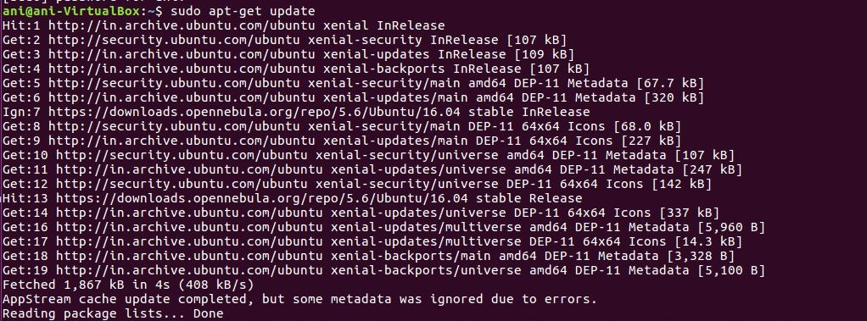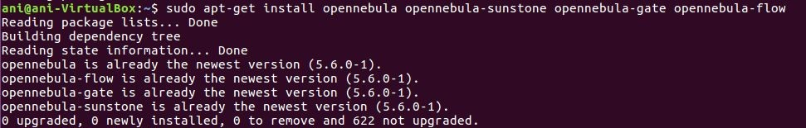

**# apt-get install opennebula opennebula-sunstone opennebula-gate opennebula-flow**

Some Open Nebula Repositories need to Ruby libraries which can be installed as:

**# /usr/share/one/install_gems**

1. **one_auth** file contains the **username and password** and it can be viewed as:



0

1. **Starting openNebula : login as oneadmin**

**# systemctl start opennebula**

**# systemctl start opennebula-sunstone**



1. **Verifying the installation:**
2. In the Front-end, run the following command as oneadmin:

$ oneuser show

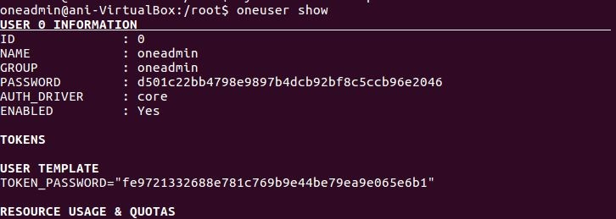

1. 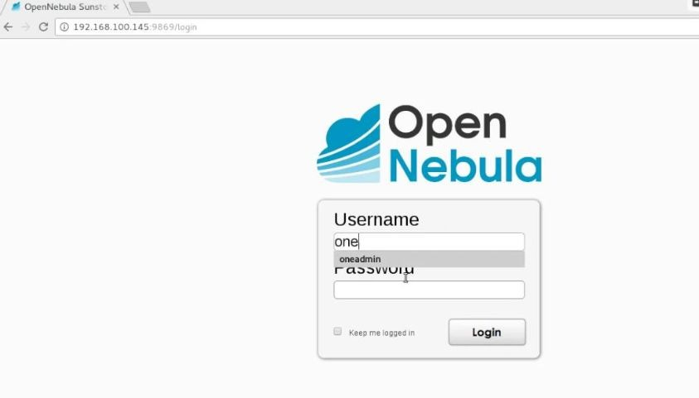In FrontEnd VM browser, give **http://localhost:9869** the following login page will open up. Login with username as **oneadmin** and the default password for the oneadmin user can be found in **~/.one/one_auth** (refer Step 3).

After successful login , the Open Nebula dashboard appears as given below:

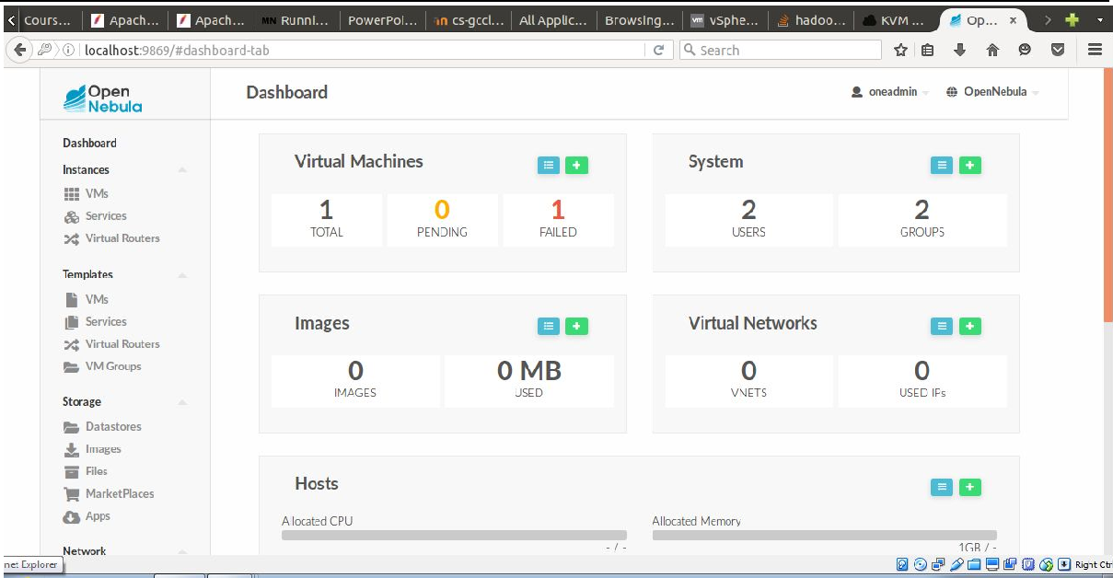

**KVM-NODE INSTALLATION**

* 1. Add Open Nebula Repositories : To add OpenNebula repository on Debian/Ubuntu execute as root:

**# wget -q -O- https://downloads.opennebula.org/repo/repo.key | apt-key add -**



* 1. Installing the software

Execute the following commands to install the node package and restart libvirt to use the OpenNebula provided configuration file:

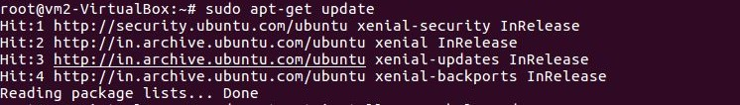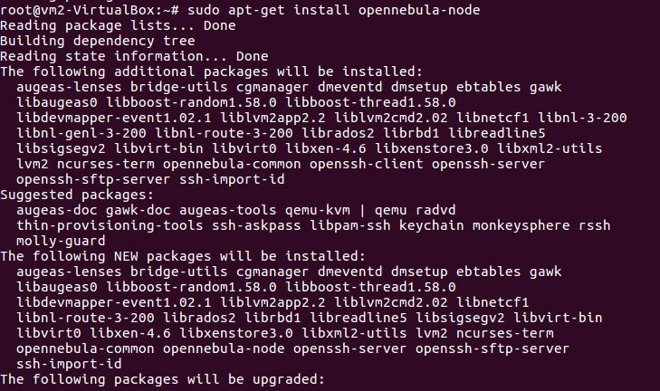

$ sudo apt-get update

$ sudo apt-get install opennebula-node

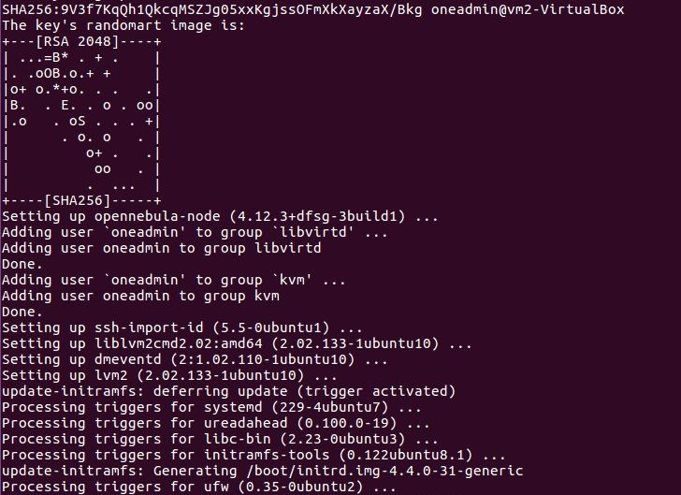

$ sudo service libvirt-bin restart



**RESULT:**

Thus front-end and KVM node installation of Opennebula is performed and verified using Ubuntu 16.04 desktop image in the two VMs.